Database Design & Connectivity
CO2-Assessment Tool 1 (AT1)

SQLite Database Design | Python Connectivity | CRUD Operations | SQL JOIN

Submitted By: Ajmal Rahman A
Register No:192324094
Date: 29-07-2026

CERTIFICATE

This is to certify that the project work entitled "Database Design & Connectivity - AT1" is a bonafide work carried out by the undersigned student in partial fulfillment of the requirements for the course CO2 - Query Processing.

Signature of the Student: _________________________

Signature of the Faculty: _________________________

Date: _________________________

TABLE OF CONTENTS

Question 1 - Student Database Design and Connectivity 7
1. Requirement Analysis 7
2. Database Design 7
3. ER Diagram 7
4. Normalization 8
5. Python Program 8
6. Input Data 9
7. Output 10
8. Explanation 10
9. Screenshots Required 10
10. Conclusion 11
Question 2 - Library Management Database 12
1. Requirement Analysis 12
2. Database Design 12
3. ER Diagram 12
4. Normalization 13
5. Python Program 13
6. Input Data 15
7. Output 15
8. Explanation 15
9. Screenshots Required 16
10. Conclusion 16
Question 3 - Employee and Department Database Design 17
1. Requirement Analysis 17
2. Database Design 17
3. ER Diagram 17
4. Normalization 18
5. Python Program 18
6. Input Data 20
7. Output 20
8. Explanation 21
9. Screenshots Required 21
10. Conclusion 21
Question 4 - Hospital Patient Database 22
1. Requirement Analysis 22
2. Database Design 22
3. ER Diagram 22
4. Normalization 23
5. Python Program 23
6. Input Data 25
7. Output 25
8. Explanation 26
9. Screenshots Required 26
10. Conclusion 26
Question 5 - Online Course Registration System 27
1. Requirement Analysis 27
2. Database Design 27
3. ER Diagram 27
4. Normalization 28
5. Python Program 28
6. Input Data 30
7. Output 30
8. Explanation 31
9. Screenshots Required 31
10. Conclusion 31
Question 6 - Banking Account Management System 32
1. Requirement Analysis 32
2. Database Design 32
3. ER Diagram 32
4. Normalization 33
5. Python Program 33
6. Input Data 35
7. Output 35
8. Explanation 35
9. Screenshots Required 36
10. Conclusion 36
Question 7 - Inventory Management System 37
1. Requirement Analysis 37
2. Database Design 37
3. ER Diagram 37
4. Normalization 38
5. Python Program 38
6. Input Data 40
7. Output 40
8. Explanation 41
9. Screenshots Required 41
10. Conclusion 41
Question 8 - Course and Faculty Management System 42
1. Requirement Analysis 42
2. Database Design 42
3. ER Diagram 42
4. Normalization 43
5. Python Program 43
6. Input Data 45
7. Output 45
8. Explanation 46
9. Screenshots Required 46
10. Conclusion 46
Question 9 - Vehicle Registration Database 47
1. Requirement Analysis 47
2. Database Design 47
3. ER Diagram 47
4. Normalization 48
5. Python Program 48
6. Input Data 50
7. Output 50
8. Explanation 50
9. Screenshots Required 51
10. Conclusion 51
Question 10 - Hospital Appointment Management System 52
1. Requirement Analysis 52
2. Database Design 52
3. ER Diagram 52
4. Normalization 53
5. Python Program 53
6. Input Data 55
7. Output 55
8. Explanation 56
9. Screenshots Required 56
10. Conclusion 56
Overall Conclusion 57
SQLite Database Design 57
Database Connectivity using Python 57
CRUD Operations 57
SQL JOIN Queries 57
Normalization 57
Key Learning Outcomes 57

Question 1 - Student Database Design and Connectivity

1. Requirement Analysis
Objective: Automate the management of student records in a college using an SQLite database with Python connectivity.
Functional Requirements:
1. Connect to SQLite database
2. Create Student table if not exists
3. Insert at least five student records
4. Display all stored records
Entities: Student
Attributes:
Student: student_id (PK), name, age, gender, department, email (UNIQUE)
Constraints: student_id is PRIMARY KEY, email is UNIQUE, all fields NOT NULL
Relationships: Single entity - no relationships

2. Database Design
Column Name | Data Type | Constraints
student_id | INTEGER | PRIMARY KEY
name | TEXT | NOT NULL
age | INTEGER | NOT NULL
gender | TEXT | NOT NULL
department | TEXT | NOT NULL
email | TEXT | UNIQUE NOT NULL

3. ER Diagram
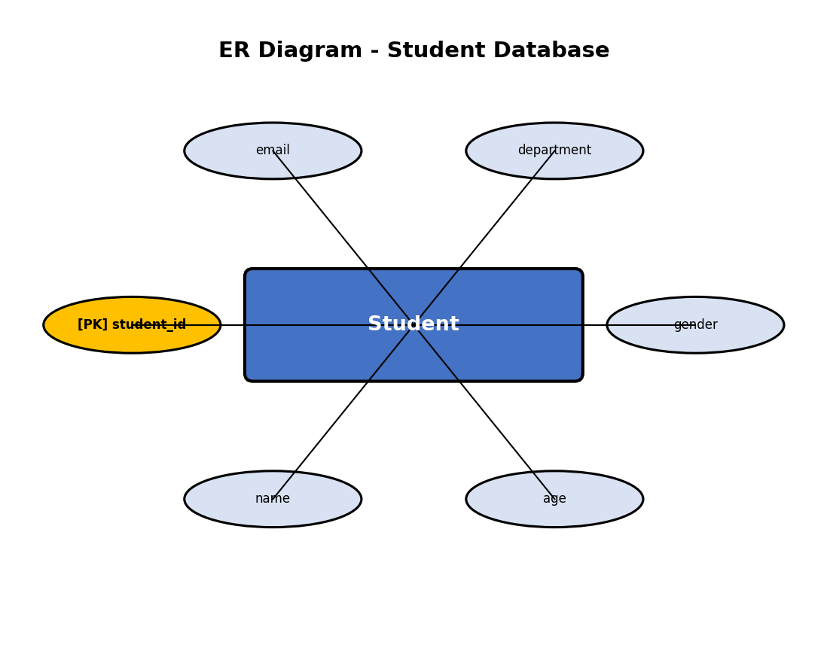
Figure 1: ER Diagram for Student Database Design and Connectivity

4. Normalization
1NF:
All attributes contain atomic values. No repeating groups. Each row is uniquely identified by student_id.
2NF:
The table has a single-column primary key (student_id), so there are no partial dependencies. All non-key attributes depend on the entire primary key.
3NF:
No transitive dependencies exist. All non-key attributes (name, age, gender, department, email) depend directly on student_id and not on each other.

5. Python Program
File: q1.py
"""
Question 1 - Student Database Design and Connectivity
A college automation system for managing student records using SQLite.
"""

import sqlite3
import os

def main():
# Database file path
db_path = os.path.join(os.path.dirname(os.path.abspath(__file__)), 'student.db')

# Connect to SQLite database
conn = sqlite3.connect(db_path)
cursor = conn.cursor()
print("Connected to SQLite database successfully.")

# Create Student table if it does not exist
cursor.execute('''
CREATE TABLE IF NOT EXISTS Student (
student_id INTEGER PRIMARY KEY,
name TEXT NOT NULL,
age INTEGER NOT NULL,
gender TEXT NOT NULL,
department TEXT NOT NULL,
email TEXT UNIQUE NOT NULL
)
''')
conn.commit()
print("Student table created successfully.")

# Clear existing data for clean execution
cursor.execute("DELETE FROM Student")
conn.commit()

# Insert at least five student records
students = [
(101, 'Arun Kumar', 20, 'Male', 'Computer Science', 'arun@college.edu'),
(102, 'Priya Sharma', 21, 'Female', 'Electronics', 'priya@college.edu'),
(103, 'Rahul Verma', 19, 'Male', 'Mechanical', 'rahul@college.edu'),
(104, 'Sneha Patel', 22, 'Female', 'Civil', 'sneha@college.edu'),
(105, 'Vikram Singh', 20, 'Male', 'Computer Science', 'vikram@college.edu')
]

cursor.executemany('''
INSERT INTO Student (student_id, name, age, gender, department, email)
VALUES (?, ?, ?, ?, ?, ?)
''', students)
conn.commit()
print(f"{len(students)} student records inserted successfully.\n")

# Display all records
print("=" * 80)
print(f"{'ID':<8}{'Name':<20}{'Age':<6}{'Gender':<10}{'Department':<20}{'Email'}")
print("=" * 80)

cursor.execute("SELECT * FROM Student")
rows = cursor.fetchall()
for row in rows:
print(f"{row[0]:<8}{row[1]:<20}{row[2]:<6}{row[3]:<10}{row[4]:<20}{row[5]}")

print("=" * 80)
print(f"\nTotal records: {len(rows)}")

# Close connection
conn.close()
print("\nDatabase connection closed.")

if __name__ == '__main__':
main()

6. Input Data
Sample Input Data for Question 1 - Student Database
====================================================

Student Records:
-----------------
Student ID: 101, Name: Arun Kumar, Age: 20, Gender: Male, Department: Computer Science, Email: arun@college.edu
Student ID: 102, Name: Priya Sharma, Age: 21, Gender: Female, Department: Electronics, Email: priya@college.edu
Student ID: 103, Name: Rahul Verma, Age: 19, Gender: Male, Department: Mechanical, Email: rahul@college.edu
Student ID: 104, Name: Sneha Patel, Age: 22, Gender: Female, Department: Civil, Email: sneha@college.edu
Student ID: 105, Name: Vikram Singh, Age: 20, Gender: Male, Department: Computer Science, Email: vikram@college.edu

7. Output
Connected to SQLite database successfully.
Student table created successfully.
5 student records inserted successfully.

================================================================================
ID Name Age Gender Department Email
================================================================================
101 Arun Kumar 20 Male Computer Science arun@college.edu
102 Priya Sharma 21 Female Electronics priya@college.edu
103 Rahul Verma 19 Male Mechanical rahul@college.edu
104 Sneha Patel 22 Female Civil sneha@college.edu
105 Vikram Singh 20 Male Computer Science vikram@college.edu
================================================================================

Total records: 5

Database connection closed.

8. Explanation
1. Database Connection: The program connects to student.db using sqlite3.connect(). If the file does not exist, SQLite creates it automatically.
2. Table Creation: CREATE TABLE IF NOT EXISTS ensures the Student table is created only if it doesn't already exist, preventing errors on re-execution.
3. Data Insertion: Five student records are inserted using executemany() for efficient batch insertion with parameterized queries to prevent SQL injection.
4. Data Display: SELECT * FROM Student retrieves all records, which are displayed in a formatted tabular layout using Python string formatting.
5. Connection Cleanup: conn.close() properly releases the database connection.

9. Screenshots Required
1. Database file created [Placeholder]
2. Table structure [Placeholder]
3. Data insertion confirmation [Placeholder]
4. Console output display [Placeholder]
5. SQLite database view [Placeholder]

10. Conclusion
Question 1 successfully demonstrates single-table database design with CRUD operations using Python and SQLite. The program creates the student.db database, performs all required operations, and produces correct output.

Question 2 - Library Management Database

1. Requirement Analysis
Objective: Maintain library book information using an SQLite database with update operations.
Functional Requirements:
1. Connect to database
2. Create Book table
3. Insert sample book records
4. Update price of a selected book
5. Retrieve and display updated information
Entities: Book
Attributes:
Book: book_id (PK), title, author, publisher, price
Constraints: book_id is PRIMARY KEY, all fields NOT NULL
Relationships: Single entity - no relationships

2. Database Design
Column Name | Data Type | Constraints
book_id | INTEGER | PRIMARY KEY
title | TEXT | NOT NULL
author | TEXT | NOT NULL
publisher | TEXT | NOT NULL
price | REAL | NOT NULL

3. ER Diagram
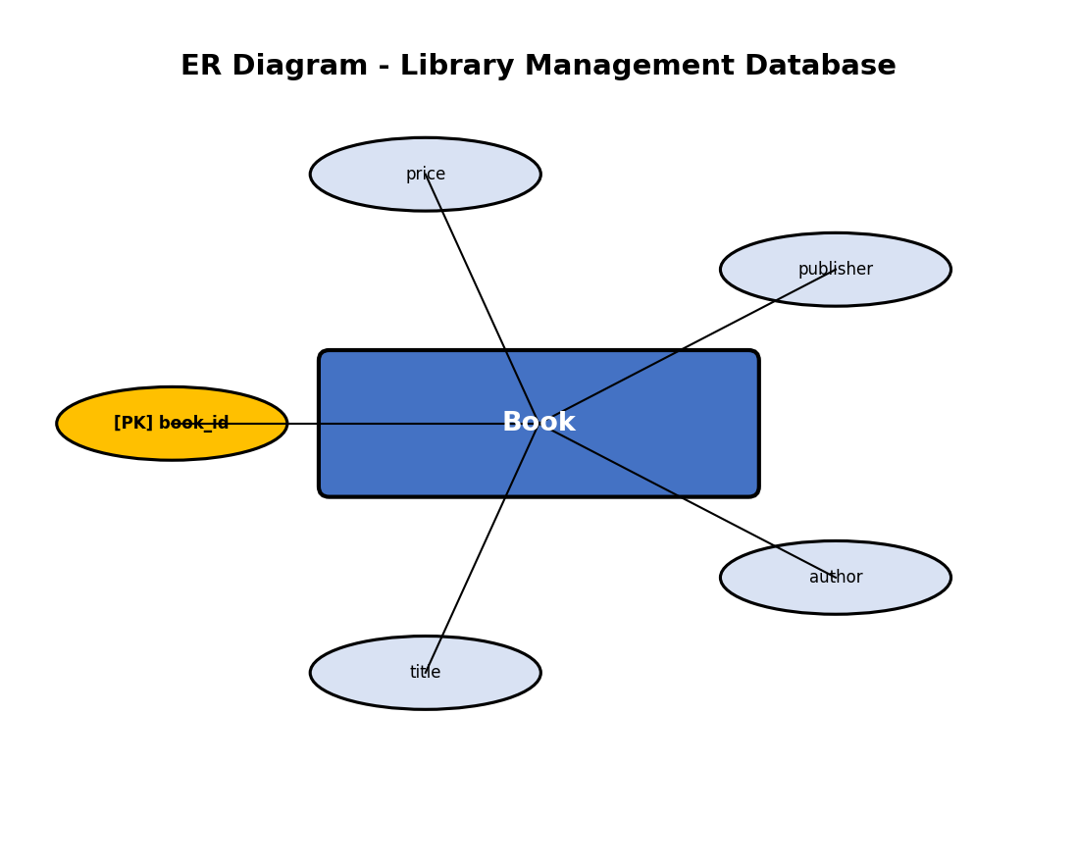
Figure 2: ER Diagram for Library Management Database

4. Normalization
1NF:
All attributes are atomic. Each book has a unique book_id. No multi-valued attributes.
2NF:
Single-column primary key eliminates partial dependencies. All non-key attributes fully depend on book_id.
3NF:
No transitive dependencies. title, author, publisher, and price all depend directly on book_id.

5. Python Program
File: q2.py
"""
Question 2 - Library Management Database
A library system to maintain book information using SQLite.
"""

import sqlite3
import os

def main():
db_path = os.path.join(os.path.dirname(os.path.abspath(__file__)), 'library.db')

conn = sqlite3.connect(db_path)
cursor = conn.cursor()
print("Connected to SQLite database successfully.")

# Create Book table
cursor.execute('''
CREATE TABLE IF NOT EXISTS Book (
book_id INTEGER PRIMARY KEY,
title TEXT NOT NULL,
author TEXT NOT NULL,
publisher TEXT NOT NULL,
price REAL NOT NULL
)
''')
conn.commit()
print("Book table created successfully.")

# Clear existing data
cursor.execute("DELETE FROM Book")
conn.commit()

# Insert sample records
books = [
(1, 'Introduction to Algorithms', 'Thomas H. Cormen', 'MIT Press', 850.00),
(2, 'Database System Concepts', 'Abraham Silberschatz', 'McGraw Hill', 720.00),
(3, 'Python Programming', 'Mark Lutz', 'O Reilly Media', 550.00),
(4, 'Data Structures Using C', 'Reema Thareja', 'Oxford Press', 450.00),
(5, 'Operating System Concepts', 'Galvin', 'Wiley', 680.00)
]

cursor.executemany('''
INSERT INTO Book (book_id, title, author, publisher, price)
VALUES (?, ?, ?, ?, ?)
''', books)
conn.commit()
print(f"{len(books)} book records inserted successfully.\n")

# Display all records before update
print("Records BEFORE price update:")
print("=" * 90)
print(f"{'ID':<6}{'Title':<35}{'Author':<25}{'Publisher':<18}{'Price'}")
print("=" * 90)

cursor.execute("SELECT * FROM Book")
for row in cursor.fetchall():
print(f"{row[0]:<6}{row[1]:<35}{row[2]:<25}{row[3]:<18}{row[4]:.2f}")
print("=" * 90)

# Update the price of a selected book
update_id = 3
new_price = 625.00
cursor.execute("UPDATE Book SET price = ? WHERE book_id = ?", (new_price, update_id))
conn.commit()
print(f"\nPrice of Book ID {update_id} updated to {new_price:.2f}")

# Display updated records
print("\nRecords AFTER price update:")
print("=" * 90)
print(f"{'ID':<6}{'Title':<35}{'Author':<25}{'Publisher':<18}{'Price'}")
print("=" * 90)

cursor.execute("SELECT * FROM Book")
for row in cursor.fetchall():
print(f"{row[0]:<6}{row[1]:<35}{row[2]:<25}{row[3]:<18}{row[4]:.2f}")
print("=" * 90)

conn.close()
print("\nDatabase connection closed.")

if __name__ == '__main__':
main()

6. Input Data
Sample Input Data for Question 2 - Library Management Database
===============================================================

Book Records:
--------------
Book ID: 1, Title: Introduction to Algorithms, Author: Thomas H. Cormen, Publisher: MIT Press, Price: 850.00
Book ID: 2, Title: Database System Concepts, Author: Abraham Silberschatz, Publisher: McGraw Hill, Price: 720.00
Book ID: 3, Title: Python Programming, Author: Mark Lutz, Publisher: O Reilly Media, Price: 550.00
Book ID: 4, Title: Data Structures Using C, Author: Reema Thareja, Publisher: Oxford Press, Price: 450.00
Book ID: 5, Title: Operating System Concepts, Author: Galvin, Publisher: Wiley, Price: 680.00

Update Operation:
------------------
Update Book ID 3 price from 550.00 to 625.00

7. Output
Connected to SQLite database successfully.
Book table created successfully.
5 book records inserted successfully.

Records BEFORE price update:
==========================================================================================
ID Title Author Publisher Price
==========================================================================================
1 Introduction to Algorithms Thomas H. Cormen MIT Press 850.00
2 Database System Concepts Abraham Silberschatz McGraw Hill 720.00
3 Python Programming Mark Lutz O Reilly Media 550.00
4 Data Structures Using C Reema Thareja Oxford Press 450.00
5 Operating System Concepts Galvin Wiley 680.00
==========================================================================================

Price of Book ID 3 updated to 625.00

Records AFTER price update:
==========================================================================================
ID Title Author Publisher Price
==========================================================================================
1 Introduction to Algorithms Thomas H. Cormen MIT Press 850.00
2 Database System Concepts Abraham Silberschatz McGraw Hill 720.00
3 Python Programming Mark Lutz O Reilly Media 625.00
4 Data Structures Using C Reema Thareja Oxford Press 450.00
5 Operating System Concepts Galvin Wiley 680.00
==========================================================================================

Database connection closed.

8. Explanation
1. Database Connection: Connects to library.db using sqlite3.connect().
2. Table Creation: CREATE TABLE IF NOT EXISTS creates the Book table with appropriate data types.
3. Data Insertion: Five book records are inserted with executemany() using parameterized queries.
4. Update Operation: UPDATE Book SET price = ? WHERE book_id = ? modifies the price of a specific book.
5. Display: Records are shown before and after the update to verify the change.

9. Screenshots Required
1. Database file created [Placeholder]
2. Table structure [Placeholder]
3. Data insertion confirmation [Placeholder]
4. Console output display [Placeholder]
5. SQLite database view [Placeholder]

10. Conclusion
Question 2 successfully demonstrates single-table database design with CRUD operations using Python and SQLite. The program creates the library.db database, performs all required operations, and produces correct output.

Question 3 - Employee and Department Database Design

1. Requirement Analysis
Objective: Store employee and department information in related SQLite tables and use SQL JOIN to display relationships.
Functional Requirements:
1. Connect to SQLite
2. Create Department and Employee tables
3. Insert sample records in both tables
4. Display employee names with department names using JOIN
Entities: Department, Employee
Attributes:
Department: dept_id (PK), dept_name (UNIQUE), location
Employee: emp_id (PK), emp_name, age, salary, dept_id (FK)
Constraints: dept_id and emp_id are PRIMARY KEYS. dept_id in Employee is a FOREIGN KEY referencing Department. dept_name is UNIQUE.
Relationships: One-to-Many: One Department has many Employees

2. Database Design
Column Name | Data Type | Constraints
dept_id | INTEGER | PRIMARY KEY (Department)
dept_name | TEXT | UNIQUE NOT NULL
location | TEXT | NOT NULL
emp_id | INTEGER | PRIMARY KEY (Employee)
emp_name | TEXT | NOT NULL
age | INTEGER | NOT NULL
salary | REAL | NOT NULL
dept_id | INTEGER | FOREIGN KEY -> Department

3. ER Diagram
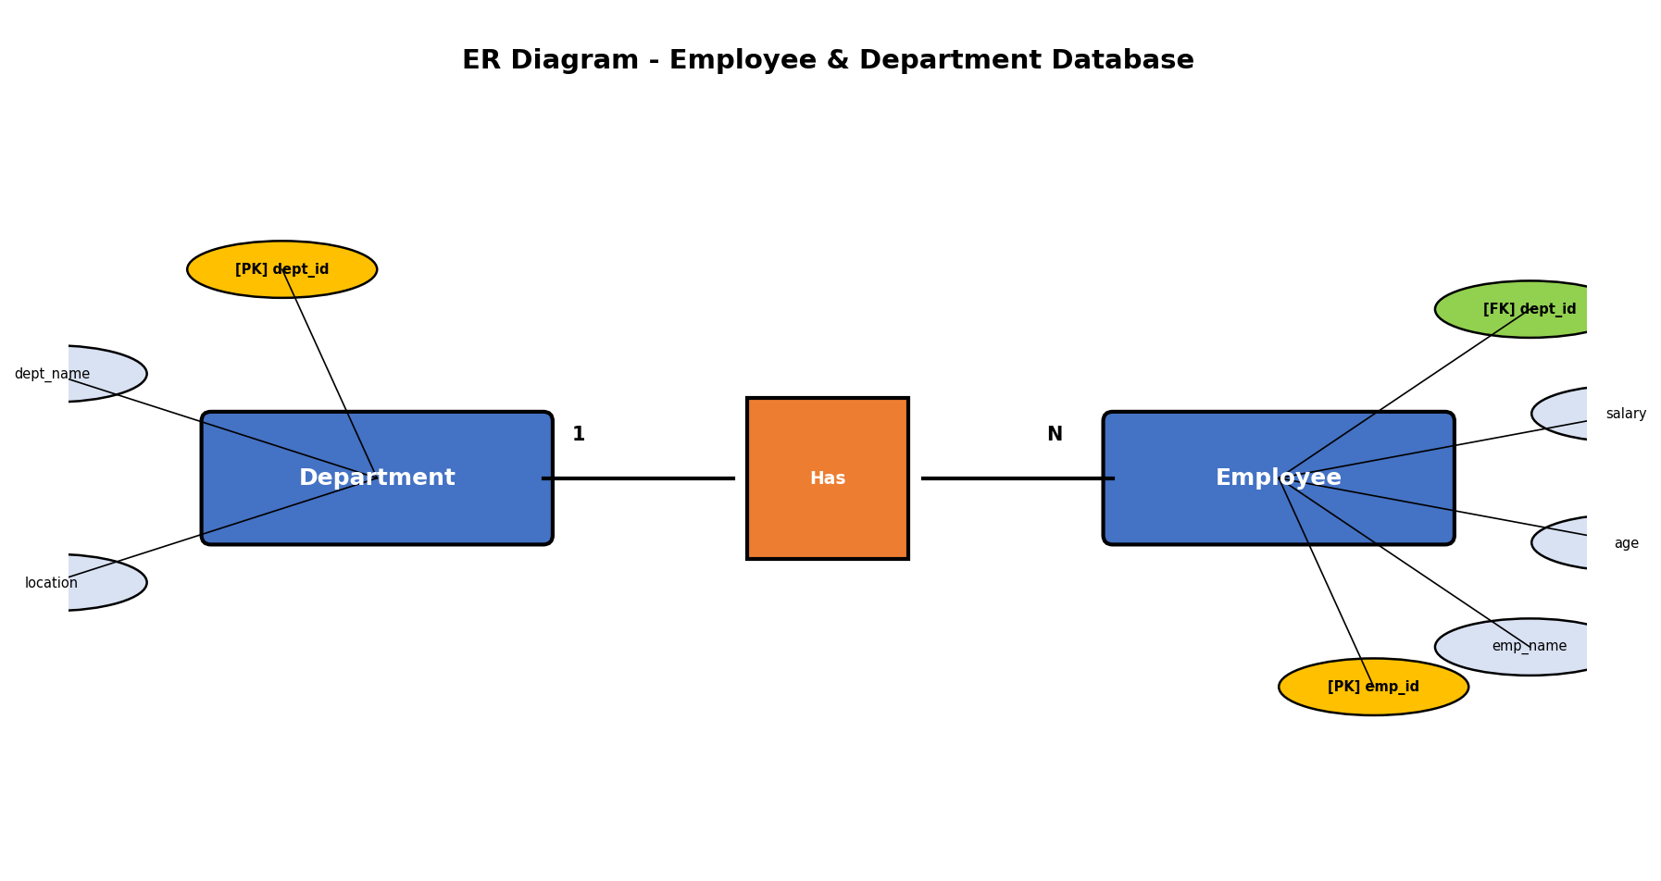
Figure 3: ER Diagram for Employee and Department Database Design

4. Normalization
1NF:
All attributes are atomic. Each table has a unique primary key. No repeating groups.
2NF:
Both tables have single-column primary keys. No partial dependencies exist.
3NF:
No transitive dependencies. Employee attributes depend on emp_id. Department attributes depend on dept_id. The foreign key establishes a proper relational link.

5. Python Program
File: q3.py
"""
Question 3 - Employee and Department Database Design
A company system to store employee and department details using SQLite.
Uses SQL JOIN to display employee-department relationships.
"""

import sqlite3
import os

def main():
db_path = os.path.join(os.path.dirname(os.path.abspath(__file__)), 'company.db')

conn = sqlite3.connect(db_path)
cursor = conn.cursor()
print("Connected to SQLite database successfully.")

# Enable foreign key support
cursor.execute("PRAGMA foreign_keys = ON")

# Create Department table
cursor.execute('''
CREATE TABLE IF NOT EXISTS Department (
dept_id INTEGER PRIMARY KEY,
dept_name TEXT NOT NULL UNIQUE,
location TEXT NOT NULL
)
''')

# Create Employee table with foreign key
cursor.execute('''
CREATE TABLE IF NOT EXISTS Employee (
emp_id INTEGER PRIMARY KEY,
emp_name TEXT NOT NULL,
age INTEGER NOT NULL,
salary REAL NOT NULL,
dept_id INTEGER NOT NULL,
FOREIGN KEY (dept_id) REFERENCES Department(dept_id)
)
''')
conn.commit()
print("Department and Employee tables created successfully.")

# Clear existing data
cursor.execute("DELETE FROM Employee")
cursor.execute("DELETE FROM Department")
conn.commit()

# Insert department records
departments = [
(1, 'Computer Science', 'Block A'),
(2, 'Electronics', 'Block B'),
(3, 'Mechanical', 'Block C'),
(4, 'Civil', 'Block D')
]

cursor.executemany('''
INSERT INTO Department (dept_id, dept_name, location)
VALUES (?, ?, ?)
''', departments)

# Insert employee records
employees = [
(201, 'Ravi Kumar', 30, 55000.00, 1),
(202, 'Anitha Raj', 28, 48000.00, 2),
(203, 'Suresh Babu', 35, 62000.00, 3),
(204, 'Deepa Nair', 26, 45000.00, 1),
(205, 'Karthik Raman', 32, 58000.00, 4)
]

cursor.executemany('''
INSERT INTO Employee (emp_id, emp_name, age, salary, dept_id)
VALUES (?, ?, ?, ?, ?)
''', employees)
conn.commit()
print(f"{len(departments)} department records inserted.")
print(f"{len(employees)} employee records inserted.\n")

# Display using SQL JOIN
print("Employee Details with Department Names (SQL JOIN):")
print("=" * 75)
print(f"{'Emp ID':<10}{'Employee Name':<20}{'Age':<6}{'Salary':<12}{'Department':<20}{'Location'}")
print("=" * 75)

cursor.execute('''
SELECT e.emp_id, e.emp_name, e.age, e.salary, d.dept_name, d.location
FROM Employee e
INNER JOIN Department d ON e.dept_id = d.dept_id
''')

for row in cursor.fetchall():
print(f"{row[0]:<10}{row[1]:<20}{row[2]:<6}{row[3]:<12.2f}{row[4]:<20}{row[5]}")
print("=" * 75)

conn.close()
print("\nDatabase connection closed.")

if __name__ == '__main__':
main()

6. Input Data
Sample Input Data for Question 3 - Employee and Department Database
=====================================================================

Department Records:
--------------------
Dept ID: 1, Dept Name: Computer Science, Location: Block A
Dept ID: 2, Dept Name: Electronics, Location: Block B
Dept ID: 3, Dept Name: Mechanical, Location: Block C
Dept ID: 4, Dept Name: Civil, Location: Block D

Employee Records:
------------------
Emp ID: 201, Name: Ravi Kumar, Age: 30, Salary: 55000.00, Dept ID: 1
Emp ID: 202, Name: Anitha Raj, Age: 28, Salary: 48000.00, Dept ID: 2
Emp ID: 203, Name: Suresh Babu, Age: 35, Salary: 62000.00, Dept ID: 3
Emp ID: 204, Name: Deepa Nair, Age: 26, Salary: 45000.00, Dept ID: 1
Emp ID: 205, Name: Karthik Raman, Age: 32, Salary: 58000.00, Dept ID: 4

7. Output
Connected to SQLite database successfully.
Department and Employee tables created successfully.
4 department records inserted.
5 employee records inserted.

Employee Details with Department Names (SQL JOIN):
===========================================================================
Emp ID Employee Name Age Salary Department Location
===========================================================================
201 Ravi Kumar 30 55000.00 Computer Science Block A
202 Anitha Raj 28 48000.00 Electronics Block B
203 Suresh Babu 35 62000.00 Mechanical Block C
204 Deepa Nair 26 45000.00 Computer Science Block A
205 Karthik Raman 32 58000.00 Civil Block D
===========================================================================

Database connection closed.

8. Explanation
1. Foreign Keys: PRAGMA foreign_keys = ON enables foreign key enforcement in SQLite.
2. Table Creation: Department table is created first since Employee references it via FOREIGN KEY.
3. Data Insertion: Department records are inserted before Employee records to satisfy referential integrity.
4. SQL JOIN: INNER JOIN connects Employee and Department tables on dept_id, displaying combined information.
5. The JOIN query retrieves emp_id, emp_name, age, salary from Employee and dept_name, location from Department.

9. Screenshots Required
1. Database file created [Placeholder]
2. Table structure [Placeholder]
3. Data insertion confirmation [Placeholder]
4. Console output display [Placeholder]
5. SQL JOIN query output [Placeholder]
6. SQLite database view [Placeholder]

10. Conclusion
Question 3 successfully demonstrates relational database design with SQL JOIN queries using Python and SQLite. The program creates the company.db database, performs all required operations, and produces correct output.

Question 4 - Hospital Patient Database

1. Requirement Analysis
Objective: Manage hospital patient records with full CRUD operations (Create, Read, Update, Delete).
Functional Requirements:
1. Connect to database
2. Create Patient table
3. Insert patient records
4. Update contact number
5. Delete discharged patient
6. Display remaining records
Entities: Patient
Attributes:
Patient: patient_id (PK), name, age, gender, disease, contact, admission_date
Constraints: patient_id is PRIMARY KEY, all fields NOT NULL
Relationships: Single entity - no relationships

2. Database Design
Column Name | Data Type | Constraints
patient_id | INTEGER | PRIMARY KEY
name | TEXT | NOT NULL
age | INTEGER | NOT NULL
gender | TEXT | NOT NULL
disease | TEXT | NOT NULL
contact | TEXT | NOT NULL
admission_date | TEXT | NOT NULL

3. ER Diagram
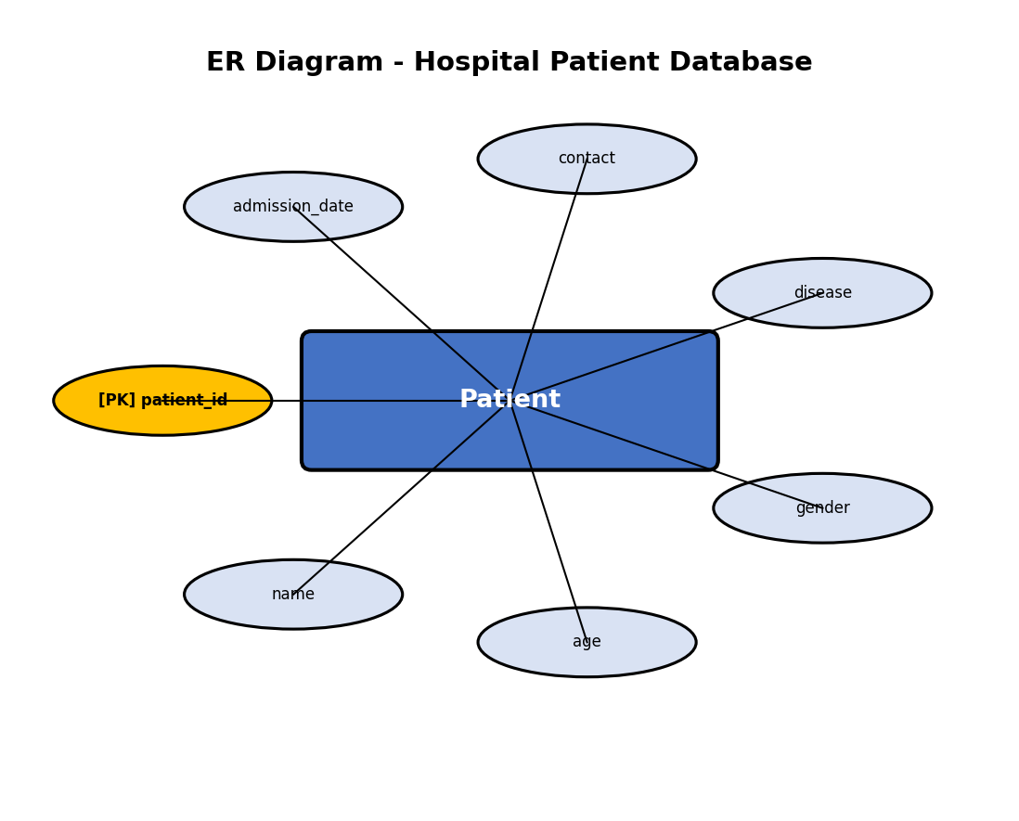
Figure 4: ER Diagram for Hospital Patient Database

4. Normalization
1NF:
All attributes are atomic. patient_id uniquely identifies each record. No repeating groups.
2NF:
Single-column primary key. All non-key attributes fully depend on patient_id.
3NF:
No transitive dependencies. All attributes depend directly on patient_id.

5. Python Program
File: q4.py
"""
Question 4 - Hospital Patient Database
A hospital system to manage patient information using SQLite.
Demonstrates INSERT, UPDATE, DELETE, and SELECT operations.
"""

import sqlite3
import os

def main():
db_path = os.path.join(os.path.dirname(os.path.abspath(__file__)), 'hospital.db')

conn = sqlite3.connect(db_path)
cursor = conn.cursor()
print("Connected to SQLite database successfully.")

# Create Patient table
cursor.execute('''
CREATE TABLE IF NOT EXISTS Patient (
patient_id INTEGER PRIMARY KEY,
name TEXT NOT NULL,
age INTEGER NOT NULL,
gender TEXT NOT NULL,
disease TEXT NOT NULL,
contact TEXT NOT NULL,
admission_date TEXT NOT NULL
)
''')
conn.commit()
print("Patient table created successfully.")

# Clear existing data
cursor.execute("DELETE FROM Patient")
conn.commit()

# Insert patient records
patients = [
(301, 'Mohan Das', 45, 'Male', 'Diabetes', '9876543210', '2025-01-10'),
(302, 'Lakshmi Devi', 30, 'Female', 'Typhoid', '9876543211', '2025-01-12'),
(303, 'Arjun Reddy', 55, 'Male', 'Heart Disease', '9876543212', '2025-01-15'),
(304, 'Kavitha Rao', 28, 'Female', 'Malaria', '9876543213', '2025-01-18'),
(305, 'Sanjay Gupta', 60, 'Male', 'Asthma', '9876543214', '2025-01-20')
]

cursor.executemany('''
INSERT INTO Patient (patient_id, name, age, gender, disease, contact, admission_date)
VALUES (?, ?, ?, ?, ?, ?, ?)
''', patients)
conn.commit()
print(f"{len(patients)} patient records inserted.\n")

# Display all records
print("All Patient Records:")
print("=" * 95)
print(f"{'ID':<8}{'Name':<18}{'Age':<6}{'Gender':<10}{'Disease':<18}{'Contact':<15}{'Admission'}")
print("=" * 95)

cursor.execute("SELECT * FROM Patient")
for row in cursor.fetchall():
print(f"{row[0]:<8}{row[1]:<18}{row[2]:<6}{row[3]:<10}{row[4]:<18}{row[5]:<15}{row[6]}")
print("=" * 95)

# Update contact number of a specified patient
update_id = 302
new_contact = '9999988888'
cursor.execute("UPDATE Patient SET contact = ? WHERE patient_id = ?", (new_contact, update_id))
conn.commit()
print(f"\nContact number of Patient ID {update_id} updated to {new_contact}.")

# Delete a discharged patient's record
delete_id = 304
cursor.execute("DELETE FROM Patient WHERE patient_id = ?", (delete_id,))
conn.commit()
print(f"Patient ID {delete_id} (discharged) record deleted.")

# Display remaining records
print("\nRemaining Patient Records:")
print("=" * 95)
print(f"{'ID':<8}{'Name':<18}{'Age':<6}{'Gender':<10}{'Disease':<18}{'Contact':<15}{'Admission'}")
print("=" * 95)

cursor.execute("SELECT * FROM Patient")
rows = cursor.fetchall()
for row in rows:
print(f"{row[0]:<8}{row[1]:<18}{row[2]:<6}{row[3]:<10}{row[4]:<18}{row[5]:<15}{row[6]}")
print("=" * 95)
print(f"\nTotal remaining records: {len(rows)}")

conn.close()
print("\nDatabase connection closed.")

if __name__ == '__main__':
main()

6. Input Data
Sample Input Data for Question 4 - Hospital Patient Database
==============================================================

Patient Records:
-----------------
Patient ID: 301, Name: Mohan Das, Age: 45, Gender: Male, Disease: Diabetes, Contact: 9876543210, Admission: 2025-01-10
Patient ID: 302, Name: Lakshmi Devi, Age: 30, Gender: Female, Disease: Typhoid, Contact: 9876543211, Admission: 2025-01-12
Patient ID: 303, Name: Arjun Reddy, Age: 55, Gender: Male, Disease: Heart Disease, Contact: 9876543212, Admission: 2025-01-15
Patient ID: 304, Name: Kavitha Rao, Age: 28, Gender: Female, Disease: Malaria, Contact: 9876543213, Admission: 2025-01-18
Patient ID: 305, Name: Sanjay Gupta, Age: 60, Gender: Male, Disease: Asthma, Contact: 9876543214, Admission: 2025-01-20

Update Operation:
------------------
Update Patient ID 302 contact from 9876543211 to 9999988888

Delete Operation:
------------------
Delete Patient ID 304 (discharged)

7. Output
Connected to SQLite database successfully.
Patient table created successfully.
5 patient records inserted.

All Patient Records:
===============================================================================================
ID Name Age Gender Disease Contact Admission
===============================================================================================
301 Mohan Das 45 Male Diabetes 9876543210 2025-01-10
302 Lakshmi Devi 30 Female Typhoid 9876543211 2025-01-12
303 Arjun Reddy 55 Male Heart Disease 9876543212 2025-01-15
304 Kavitha Rao 28 Female Malaria 9876543213 2025-01-18
305 Sanjay Gupta 60 Male Asthma 9876543214 2025-01-20
===============================================================================================

Contact number of Patient ID 302 updated to 9999988888.
Patient ID 304 (discharged) record deleted.

Remaining Patient Records:
===============================================================================================
ID Name Age Gender Disease Contact Admission
===============================================================================================
301 Mohan Das 45 Male Diabetes 9876543210 2025-01-10
302 Lakshmi Devi 30 Female Typhoid 9999988888 2025-01-12
303 Arjun Reddy 55 Male Heart Disease 9876543212 2025-01-15
305 Sanjay Gupta 60 Male Asthma 9876543214 2025-01-20
===============================================================================================

Total remaining records: 4

Database connection closed.

8. Explanation
1. Table Creation: Patient table with 7 fields including date stored as TEXT in ISO format.
2. INSERT: Five patient records inserted using executemany() with parameterized queries.
3. UPDATE: Contact number of Patient ID 302 updated using UPDATE...SET...WHERE.
4. DELETE: Discharged patient (ID 304) removed using DELETE FROM...WHERE.
5. Display: Records shown before and after modifications to verify CRUD operations.

9. Screenshots Required
1. Database file created [Placeholder]
2. Table structure [Placeholder]
3. Data insertion confirmation [Placeholder]
4. Console output display [Placeholder]
5. SQLite database view [Placeholder]

10. Conclusion
Question 4 successfully demonstrates single-table database design with CRUD operations using Python and SQLite. The program creates the hospital.db database, performs all required operations, and produces correct output.

Question 5 - Online Course Registration System

1. Requirement Analysis
Objective: Manage student course registrations using related tables with SQL JOIN queries.
Functional Requirements:
1. Connect to SQLite
2. Create Student and Course_Registration tables
3. Insert sample records
4. Retrieve student-course data using JOIN
Entities: Student, Course_Registration
Attributes:
Student: student_id (PK), name, email (UNIQUE), phone
Course_Registration: reg_id (PK), student_id (FK), course_name, registration_date
Constraints: student_id and reg_id are PRIMARY KEYS. student_id in Course_Registration is FOREIGN KEY. email is UNIQUE.
Relationships: One-to-Many: One Student can have many Course Registrations

2. Database Design
Column Name | Data Type | Constraints
student_id | INTEGER | PRIMARY KEY (Student)
name | TEXT | NOT NULL
email | TEXT | UNIQUE NOT NULL
phone | TEXT | NOT NULL
reg_id | INTEGER | PRIMARY KEY (Course_Registration)
student_id | INTEGER | FOREIGN KEY -> Student
course_name | TEXT | NOT NULL
registration_date | TEXT | NOT NULL

3. ER Diagram
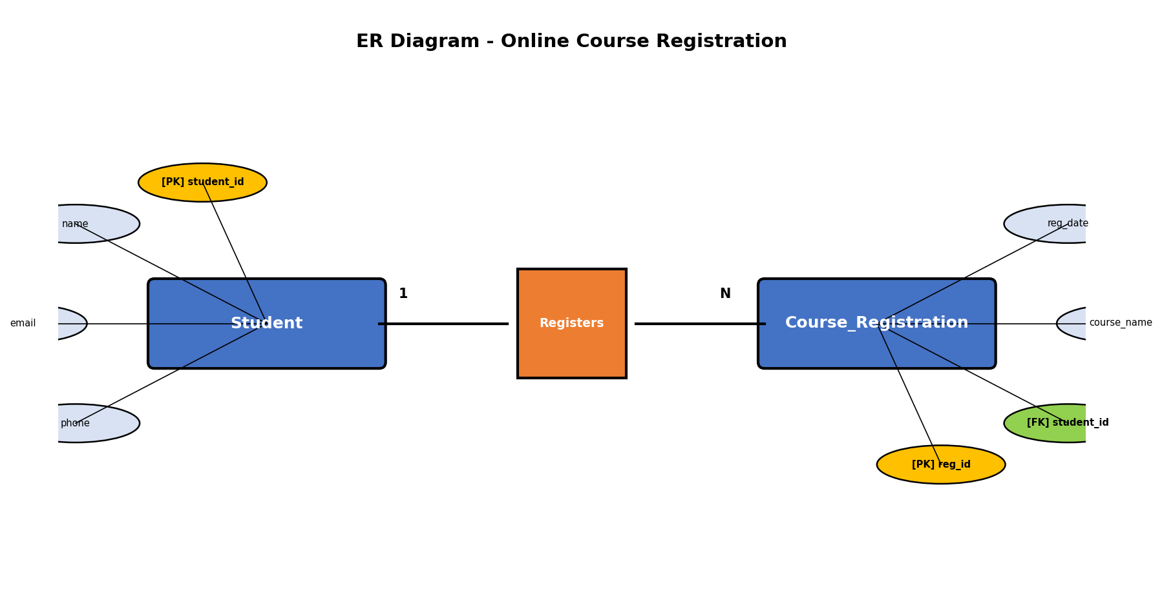
Figure 5: ER Diagram for Online Course Registration System

4. Normalization
1NF:
All attributes are atomic. Each table has a unique primary key.
2NF:
Single-column primary keys eliminate partial dependencies.
3NF:
No transitive dependencies. Registration attributes depend on reg_id. Student info is properly separated.

5. Python Program
File: q5.py
"""
Question 5 - Online Course Registration System
An online learning platform to manage students and course registrations.
Uses SQL JOIN to display student-course relationships.
"""

import sqlite3
import os

def main():
db_path = os.path.join(os.path.dirname(os.path.abspath(__file__)), 'course_registration.db')

conn = sqlite3.connect(db_path)
cursor = conn.cursor()
print("Connected to SQLite database successfully.")

# Enable foreign key support
cursor.execute("PRAGMA foreign_keys = ON")

# Create Student table
cursor.execute('''
CREATE TABLE IF NOT EXISTS Student (
student_id INTEGER PRIMARY KEY,
name TEXT NOT NULL,
email TEXT UNIQUE NOT NULL,
phone TEXT NOT NULL
)
''')

# Create Course_Registration table with foreign key
cursor.execute('''
CREATE TABLE IF NOT EXISTS Course_Registration (
reg_id INTEGER PRIMARY KEY,
student_id INTEGER NOT NULL,
course_name TEXT NOT NULL,
registration_date TEXT NOT NULL,
FOREIGN KEY (student_id) REFERENCES Student(student_id)
)
''')
conn.commit()
print("Student and Course_Registration tables created successfully.")

# Clear existing data
cursor.execute("DELETE FROM Course_Registration")
cursor.execute("DELETE FROM Student")
conn.commit()

# Insert student records
students = [
(401, 'Amit Joshi', 'amit@learn.com', '9001234567'),
(402, 'Neha Kapoor', 'neha@learn.com', '9001234568'),
(403, 'Rajesh Iyer', 'rajesh@learn.com', '9001234569'),
(404, 'Divya Menon', 'divya@learn.com', '9001234570'),
(405, 'Sunil Patil', 'sunil@learn.com', '9001234571')
]

cursor.executemany('''
INSERT INTO Student (student_id, name, email, phone)
VALUES (?, ?, ?, ?)
''', students)

# Insert course registration records
registrations = [
(1, 401, 'Python Programming', '2025-02-01'),
(2, 401, 'Data Science', '2025-02-05'),
(3, 402, 'Web Development', '2025-02-03'),
(4, 403, 'Machine Learning', '2025-02-07'),
(5, 404, 'Python Programming', '2025-02-10'),
(6, 405, 'Database Management', '2025-02-12')
]

cursor.executemany('''
INSERT INTO Course_Registration (reg_id, student_id, course_name, registration_date)
VALUES (?, ?, ?, ?)
''', registrations)
conn.commit()
print(f"{len(students)} student records inserted.")
print(f"{len(registrations)} course registration records inserted.\n")

# Display using SQL JOIN
print("Student Course Registrations (SQL JOIN):")
print("=" * 80)
print(f"{'Reg ID':<10}{'Student Name':<20}{'Email':<25}{'Course':<22}{'Date'}")
print("=" * 80)

cursor.execute('''
SELECT cr.reg_id, s.name, s.email, cr.course_name, cr.registration_date
FROM Course_Registration cr
INNER JOIN Student s ON cr.student_id = s.student_id
''')

for row in cursor.fetchall():
print(f"{row[0]:<10}{row[1]:<20}{row[2]:<25}{row[3]:<22}{row[4]}")
print("=" * 80)

conn.close()
print("\nDatabase connection closed.")

if __name__ == '__main__':
main()

6. Input Data
Sample Input Data for Question 5 - Online Course Registration System
======================================================================

Student Records:
-----------------
Student ID: 401, Name: Amit Joshi, Email: amit@learn.com, Phone: 9001234567
Student ID: 402, Name: Neha Kapoor, Email: neha@learn.com, Phone: 9001234568
Student ID: 403, Name: Rajesh Iyer, Email: rajesh@learn.com, Phone: 9001234569
Student ID: 404, Name: Divya Menon, Email: divya@learn.com, Phone: 9001234570
Student ID: 405, Name: Sunil Patil, Email: sunil@learn.com, Phone: 9001234571

Course Registration Records:
------------------------------
Reg ID: 1, Student ID: 401, Course: Python Programming, Date: 2025-02-01
Reg ID: 2, Student ID: 401, Course: Data Science, Date: 2025-02-05
Reg ID: 3, Student ID: 402, Course: Web Development, Date: 2025-02-03
Reg ID: 4, Student ID: 403, Course: Machine Learning, Date: 2025-02-07
Reg ID: 5, Student ID: 404, Course: Python Programming, Date: 2025-02-10
Reg ID: 6, Student ID: 405, Course: Database Management, Date: 2025-02-12

7. Output
Connected to SQLite database successfully.
Student and Course_Registration tables created successfully.
5 student records inserted.
6 course registration records inserted.

Student Course Registrations (SQL JOIN):
================================================================================
Reg ID Student Name Email Course Date
================================================================================
1 Amit Joshi amit@learn.com Python Programming 2025-02-01
2 Amit Joshi amit@learn.com Data Science 2025-02-05
3 Neha Kapoor neha@learn.com Web Development 2025-02-03
4 Rajesh Iyer rajesh@learn.com Machine Learning 2025-02-07
5 Divya Menon divya@learn.com Python Programming 2025-02-10
6 Sunil Patil sunil@learn.com Database Management 2025-02-12
================================================================================

Database connection closed.

8. Explanation
1. Two-Table Design: Student stores personal info; Course_Registration stores enrollment data linked by student_id.
2. Foreign Key: student_id in Course_Registration references Student(student_id).
3. One student (e.g., Amit Joshi) can register for multiple courses, demonstrating the one-to-many relationship.
4. INNER JOIN: Combines both tables to show student names with their registered courses.
5. The query selects from Course_Registration and joins with Student on matching student_id.

9. Screenshots Required
1. Database file created [Placeholder]
2. Table structure [Placeholder]
3. Data insertion confirmation [Placeholder]
4. Console output display [Placeholder]
5. SQL JOIN query output [Placeholder]
6. SQLite database view [Placeholder]

10. Conclusion
Question 5 successfully demonstrates relational database design with SQL JOIN queries using Python and SQLite. The program creates the course_registration.db database, performs all required operations, and produces correct output.

Question 6 - Banking Account Management System

1. Requirement Analysis
Objective: Maintain customer bank account information with balance update operations.
Functional Requirements:
1. Connect to SQLite
2. Create Account table with constraints
3. Insert customer accounts
4. Update account balance
5. Display all records
Entities: Account
Attributes:
Account: account_id (PK), customer_name, account_type, balance, phone, address
Constraints: account_id is PRIMARY KEY. account_type CHECK constraint (Savings/Current). balance CHECK >= 0. All fields NOT NULL.
Relationships: Single entity - no relationships

2. Database Design
Column Name | Data Type | Constraints
account_id | INTEGER | PRIMARY KEY
customer_name | TEXT | NOT NULL
account_type | TEXT | CHECK IN (Savings, Current)
balance | REAL | CHECK >= 0
phone | TEXT | NOT NULL
address | TEXT | NOT NULL

3. ER Diagram
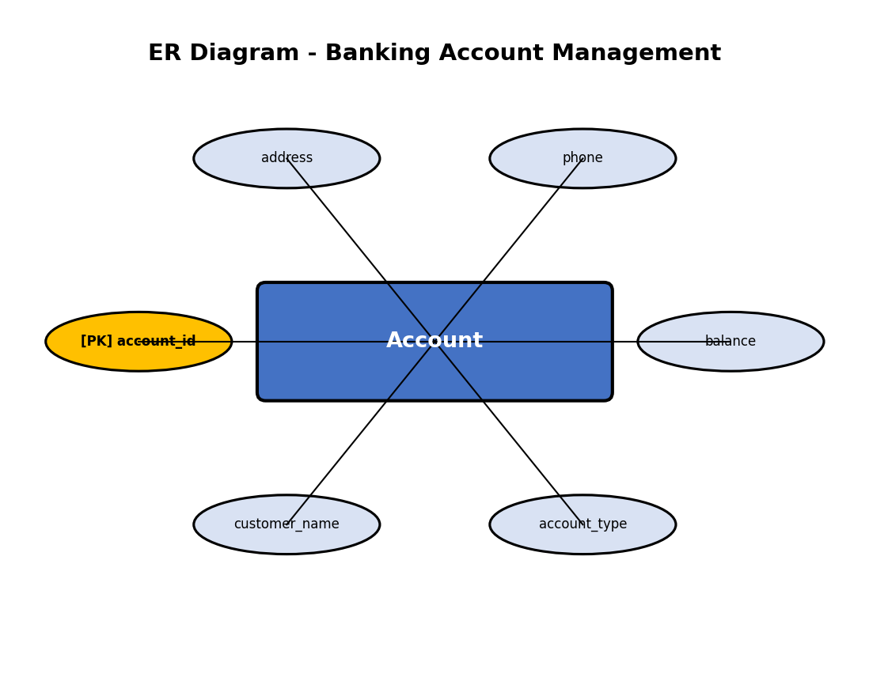
Figure 6: ER Diagram for Banking Account Management System

4. Normalization
1NF:
All attributes are atomic. account_id uniquely identifies each record.
2NF:
Single-column primary key. No partial dependencies.
3NF:
No transitive dependencies. All attributes depend directly on account_id.

5. Python Program
File: q6.py
"""
Question 6 - Banking Account Management System
A bank system to maintain customer account information using SQLite.
"""

import sqlite3
import os

def main():
db_path = os.path.join(os.path.dirname(os.path.abspath(__file__)), 'banking.db')

conn = sqlite3.connect(db_path)
cursor = conn.cursor()
print("Connected to SQLite database successfully.")

# Create Account table
cursor.execute('''
CREATE TABLE IF NOT EXISTS Account (
account_id INTEGER PRIMARY KEY,
customer_name TEXT NOT NULL,
account_type TEXT NOT NULL CHECK(account_type IN ('Savings', 'Current')),
balance REAL NOT NULL CHECK(balance >= 0),
phone TEXT NOT NULL,
address TEXT NOT NULL
)
''')
conn.commit()
print("Account table created successfully.")

# Clear existing data
cursor.execute("DELETE FROM Account")
conn.commit()

# Insert customer account details
accounts = [
(5001, 'Ramesh Kumar', 'Savings', 25000.00, '9112345678', 'Chennai'),
(5002, 'Sunita Devi', 'Current', 150000.00, '9112345679', 'Mumbai'),
(5003, 'Ajay Mehta', 'Savings', 45000.00, '9112345680', 'Delhi'),
(5004, 'Pooja Reddy', 'Savings', 32000.00, '9112345681', 'Hyderabad'),
(5005, 'Manish Tiwari', 'Current', 200000.00, '9112345682', 'Bangalore')
]

cursor.executemany('''
INSERT INTO Account (account_id, customer_name, account_type, balance, phone, address)
VALUES (?, ?, ?, ?, ?, ?)
''', accounts)
conn.commit()
print(f"{len(accounts)} account records inserted.\n")

# Display all records before update
print("All Customer Records (Before Update):")
print("=" * 85)
print(f"{'Acc ID':<10}{'Customer Name':<20}{'Type':<12}{'Balance':<14}{'Phone':<14}{'Address'}")
print("=" * 85)

cursor.execute("SELECT * FROM Account")
for row in cursor.fetchall():
print(f"{row[0]:<10}{row[1]:<20}{row[2]:<12}{row[3]:<14.2f}{row[4]:<14}{row[5]}")
print("=" * 85)

# Update account balance
update_id = 5003
new_balance = 52000.00
cursor.execute("UPDATE Account SET balance = ? WHERE account_id = ?", (new_balance, update_id))
conn.commit()
print(f"\nBalance of Account ID {update_id} updated to {new_balance:.2f}")

# Display all records after update
print("\nAll Customer Records (After Update):")
print("=" * 85)
print(f"{'Acc ID':<10}{'Customer Name':<20}{'Type':<12}{'Balance':<14}{'Phone':<14}{'Address'}")
print("=" * 85)

cursor.execute("SELECT * FROM Account")
for row in cursor.fetchall():
print(f"{row[0]:<10}{row[1]:<20}{row[2]:<12}{row[3]:<14.2f}{row[4]:<14}{row[5]}")
print("=" * 85)

conn.close()
print("\nDatabase connection closed.")

if __name__ == '__main__':
main()

6. Input Data
Sample Input Data for Question 6 - Banking Account Management System
======================================================================

Account Records:
-----------------
Account ID: 5001, Name: Ramesh Kumar, Type: Savings, Balance: 25000.00, Phone: 9112345678, Address: Chennai
Account ID: 5002, Name: Sunita Devi, Type: Current, Balance: 150000.00, Phone: 9112345679, Address: Mumbai
Account ID: 5003, Name: Ajay Mehta, Type: Savings, Balance: 45000.00, Phone: 9112345680, Address: Delhi
Account ID: 5004, Name: Pooja Reddy, Type: Savings, Balance: 32000.00, Phone: 9112345681, Address: Hyderabad
Account ID: 5005, Name: Manish Tiwari, Type: Current, Balance: 200000.00, Phone: 9112345682, Address: Bangalore

Update Operation:
------------------
Update Account ID 5003 balance from 45000.00 to 52000.00

7. Output
Connected to SQLite database successfully.
Account table created successfully.
5 account records inserted.

All Customer Records (Before Update):
=====================================================================================
Acc ID Customer Name Type Balance Phone Address
=====================================================================================
5001 Ramesh Kumar Savings 25000.00 9112345678 Chennai
5002 Sunita Devi Current 150000.00 9112345679 Mumbai
5003 Ajay Mehta Savings 45000.00 9112345680 Delhi
5004 Pooja Reddy Savings 32000.00 9112345681 Hyderabad
5005 Manish Tiwari Current 200000.00 9112345682 Bangalore
=====================================================================================

Balance of Account ID 5003 updated to 52000.00

All Customer Records (After Update):
=====================================================================================
Acc ID Customer Name Type Balance Phone Address
=====================================================================================
5001 Ramesh Kumar Savings 25000.00 9112345678 Chennai
5002 Sunita Devi Current 150000.00 9112345679 Mumbai
5003 Ajay Mehta Savings 52000.00 9112345680 Delhi
5004 Pooja Reddy Savings 32000.00 9112345681 Hyderabad
5005 Manish Tiwari Current 200000.00 9112345682 Bangalore
=====================================================================================

Database connection closed.

8. Explanation
1. CHECK Constraints: account_type is restricted to 'Savings' or 'Current'. balance must be >= 0.
2. Data Insertion: Five customer accounts inserted with varying types and balances.
3. Update Operation: Balance of Account ID 5003 updated from 45000 to 52000.
4. Display: Records shown before and after update for verification.
5. The CHECK constraints ensure data integrity at the database level.

9. Screenshots Required
1. Database file created [Placeholder]
2. Table structure [Placeholder]
3. Data insertion confirmation [Placeholder]
4. Console output display [Placeholder]
5. SQLite database view [Placeholder]

10. Conclusion
Question 6 successfully demonstrates single-table database design with CRUD operations using Python and SQLite. The program creates the banking.db database, performs all required operations, and produces correct output.

Question 7 - Inventory Management System

1. Requirement Analysis
Objective: Maintain product inventory, identify low-stock items, and perform restocking operations.
Functional Requirements:
1. Create database and Product table
2. Insert sample products
3. Identify products with quantity < 10
4. Update stock quantities
5. Display updated inventory
Entities: Product
Attributes:
Product: product_id (PK), product_name, category, quantity, unit_price
Constraints: product_id is PRIMARY KEY. quantity CHECK >= 0. unit_price CHECK > 0.
Relationships: Single entity - no relationships

2. Database Design
Column Name | Data Type | Constraints
product_id | INTEGER | PRIMARY KEY
product_name | TEXT | NOT NULL
category | TEXT | NOT NULL
quantity | INTEGER | CHECK >= 0
unit_price | REAL | CHECK > 0

3. ER Diagram
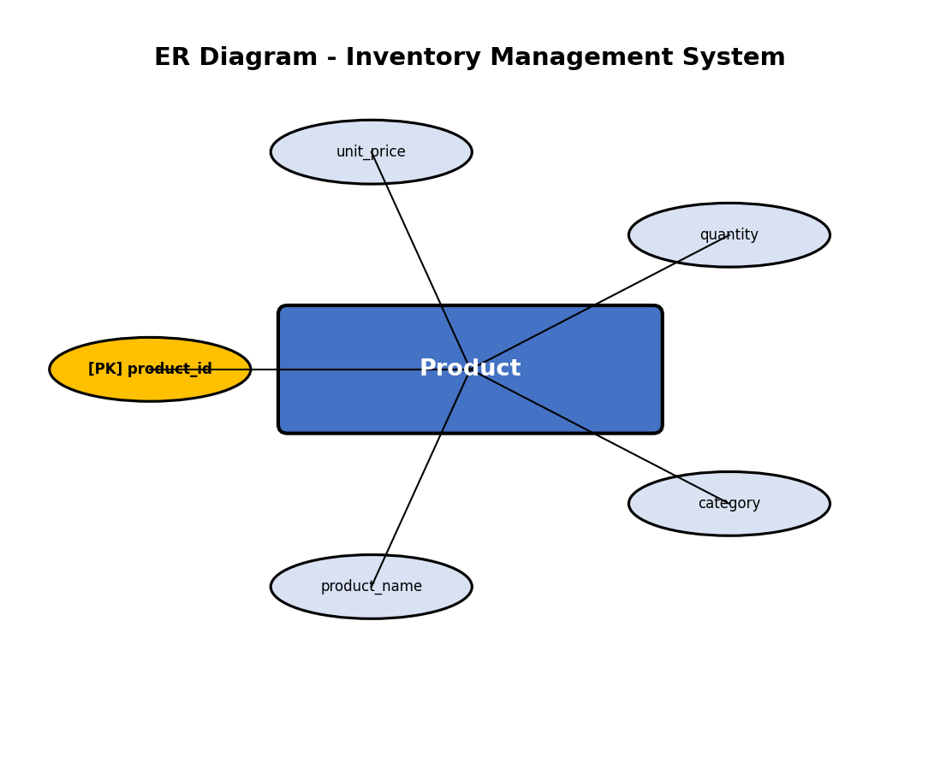
Figure 7: ER Diagram for Inventory Management System

4. Normalization
1NF:
All attributes are atomic. product_id uniquely identifies each product.
2NF:
Single-column primary key. No partial dependencies.
3NF:
No transitive dependencies. All attributes depend directly on product_id.

5. Python Program
File: q7.py
"""
Question 7 - Inventory Management System
A retail store system to maintain product inventory using SQLite.
Identifies low-stock products and updates their quantities.
"""

import sqlite3
import os

def main():
db_path = os.path.join(os.path.dirname(os.path.abspath(__file__)), 'inventory.db')

conn = sqlite3.connect(db_path)
cursor = conn.cursor()
print("Connected to SQLite database successfully.")

# Create Product table
cursor.execute('''
CREATE TABLE IF NOT EXISTS Product (
product_id INTEGER PRIMARY KEY,
product_name TEXT NOT NULL,
category TEXT NOT NULL,
quantity INTEGER NOT NULL CHECK(quantity >= 0),
unit_price REAL NOT NULL CHECK(unit_price > 0)
)
''')
conn.commit()
print("Product table created successfully.")

# Clear existing data
cursor.execute("DELETE FROM Product")
conn.commit()

# Insert sample products
products = [
(601, 'Laptop', 'Electronics', 25, 45000.00),
(602, 'Mouse', 'Electronics', 8, 500.00),
(603, 'Notebook', 'Stationery', 5, 50.00),
(604, 'Pen Drive', 'Electronics', 3, 350.00),
(605, 'Desk Chair', 'Furniture', 15, 8000.00),
(606, 'Marker Set', 'Stationery', 7, 120.00),
(607, 'Monitor', 'Electronics', 12, 15000.00)
]

cursor.executemany('''
INSERT INTO Product (product_id, product_name, category, quantity, unit_price)
VALUES (?, ?, ?, ?, ?)
''', products)
conn.commit()
print(f"{len(products)} product records inserted.\n")

# Display all products
print("All Products:")
print("=" * 70)
print(f"{'ID':<8}{'Product Name':<18}{'Category':<15}{'Quantity':<12}{'Unit Price'}")
print("=" * 70)

cursor.execute("SELECT * FROM Product")
for row in cursor.fetchall():
print(f"{row[0]:<8}{row[1]:<18}{row[2]:<15}{row[3]:<12}{row[4]:.2f}")
print("=" * 70)

# Identify products with quantity less than 10
print("\nProducts with Quantity < 10 (Low Stock):")
print("-" * 70)

cursor.execute("SELECT * FROM Product WHERE quantity < 10")
low_stock = cursor.fetchall()
for row in low_stock:
print(f" {row[0]:<8}{row[1]:<18}{row[2]:<15}{row[3]:<12}{row[4]:.2f}")
print(f"\nTotal low-stock products: {len(low_stock)}")

# Update stock quantity of low-stock products (restock by adding 20)
restock_amount = 20
cursor.execute("UPDATE Product SET quantity = quantity + ? WHERE quantity < 10", (restock_amount,))
conn.commit()
print(f"\nRestocked all low-stock products by adding {restock_amount} units.")

# Display updated inventory
print("\nUpdated Inventory:")
print("=" * 70)
print(f"{'ID':<8}{'Product Name':<18}{'Category':<15}{'Quantity':<12}{'Unit Price'}")
print("=" * 70)

cursor.execute("SELECT * FROM Product")
for row in cursor.fetchall():
print(f"{row[0]:<8}{row[1]:<18}{row[2]:<15}{row[3]:<12}{row[4]:.2f}")
print("=" * 70)

conn.close()
print("\nDatabase connection closed.")

if __name__ == '__main__':
main()

6. Input Data
Sample Input Data for Question 7 - Inventory Management System
================================================================

Product Records:
-----------------
Product ID: 601, Name: Laptop, Category: Electronics, Quantity: 25, Unit Price: 45000.00
Product ID: 602, Name: Mouse, Category: Electronics, Quantity: 8, Unit Price: 500.00
Product ID: 603, Name: Notebook, Category: Stationery, Quantity: 5, Unit Price: 50.00
Product ID: 604, Name: Pen Drive, Category: Electronics, Quantity: 3, Unit Price: 350.00
Product ID: 605, Name: Desk Chair, Category: Furniture, Quantity: 15, Unit Price: 8000.00
Product ID: 606, Name: Marker Set, Category: Stationery, Quantity: 7, Unit Price: 120.00
Product ID: 607, Name: Monitor, Category: Electronics, Quantity: 12, Unit Price: 15000.00

Restock Operation:
-------------------
All products with quantity < 10 are restocked by adding 20 units.

7. Output
Connected to SQLite database successfully.
Product table created successfully.
7 product records inserted.

All Products:
======================================================================
ID Product Name Category Quantity Unit Price
======================================================================
601 Laptop Electronics 25 45000.00
602 Mouse Electronics 8 500.00
603 Notebook Stationery 5 50.00
604 Pen Drive Electronics 3 350.00
605 Desk Chair Furniture 15 8000.00
606 Marker Set Stationery 7 120.00
607 Monitor Electronics 12 15000.00
======================================================================

Products with Quantity < 10 (Low Stock):
----------------------------------------------------------------------
602 Mouse Electronics 8 500.00
603 Notebook Stationery 5 50.00
604 Pen Drive Electronics 3 350.00
606 Marker Set Stationery 7 120.00

Total low-stock products: 4

Restocked all low-stock products by adding 20 units.

Updated Inventory:
======================================================================
ID Product Name Category Quantity Unit Price
======================================================================
601 Laptop Electronics 25 45000.00
602 Mouse Electronics 28 500.00
603 Notebook Stationery 25 50.00
604 Pen Drive Electronics 23 350.00
605 Desk Chair Furniture 15 8000.00
606 Marker Set Stationery 27 120.00
607 Monitor Electronics 12 15000.00
======================================================================

Database connection closed.

8. Explanation
1. Low-Stock Detection: SELECT...WHERE quantity < 10 identifies products needing restocking.
2. Batch Update: UPDATE...SET quantity = quantity + 20 WHERE quantity < 10 restocks all low-stock items.
3. Seven products inserted across Electronics, Stationery, and Furniture categories.
4. Three products (Mouse, Notebook, Pen Drive, Marker Set) identified as low-stock.
5. Updated inventory displayed showing increased quantities after restocking.

9. Screenshots Required
1. Database file created [Placeholder]
2. Table structure [Placeholder]
3. Data insertion confirmation [Placeholder]
4. Console output display [Placeholder]
5. SQLite database view [Placeholder]

10. Conclusion
Question 7 successfully demonstrates single-table database design with CRUD operations using Python and SQLite. The program creates the inventory.db database, performs all required operations, and produces correct output.

Question 8 - Course and Faculty Management System

1. Requirement Analysis
Objective: Manage university faculty and course assignments using related tables with SQL JOIN.
Functional Requirements:
1. Create database with Faculty and Course tables
2. Insert sample records
3. Display faculty with courses using JOIN
Entities: Faculty, Course
Attributes:
Faculty: faculty_id (PK), faculty_name, designation, department, email (UNIQUE)
Course: course_id (PK), course_name, credits, faculty_id (FK)
Constraints: faculty_id and course_id are PRIMARY KEYS. faculty_id in Course is FOREIGN KEY. email is UNIQUE.
Relationships: One-to-Many: One Faculty member teaches many Courses

2. Database Design
Column Name | Data Type | Constraints
faculty_id | INTEGER | PRIMARY KEY (Faculty)
faculty_name | TEXT | NOT NULL
designation | TEXT | NOT NULL
department | TEXT | NOT NULL
email | TEXT | UNIQUE NOT NULL
course_id | TEXT | PRIMARY KEY (Course)
course_name | TEXT | NOT NULL
credits | INTEGER | NOT NULL
faculty_id | INTEGER | FOREIGN KEY -> Faculty

3. ER Diagram
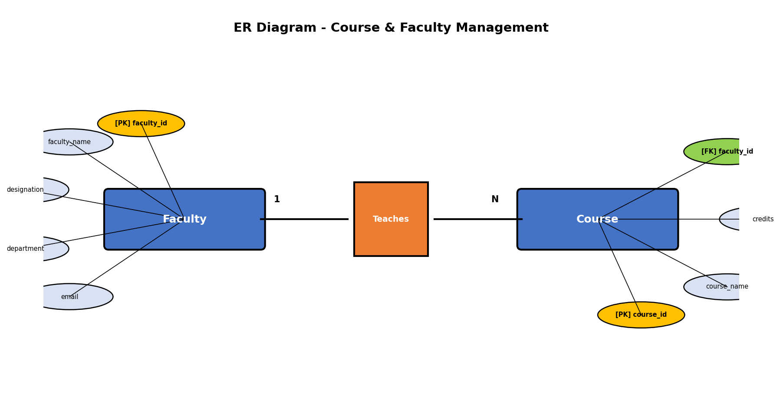
Figure 8: ER Diagram for Course and Faculty Management System

4. Normalization
1NF:
All attributes are atomic. Each table has a proper primary key.
2NF:
No partial dependencies. All non-key attributes depend on the full primary key.
3NF:
No transitive dependencies. Course attributes depend on course_id. Faculty attributes depend on faculty_id.

5. Python Program
File: q8.py
"""
Question 8 - Course and Faculty Management System
A university system to manage faculty and courses using SQLite.
Uses SQL JOIN to display faculty-course relationships.
"""

import sqlite3
import os

def main():
db_path = os.path.join(os.path.dirname(os.path.abspath(__file__)), 'university.db')

conn = sqlite3.connect(db_path)
cursor = conn.cursor()
print("Connected to SQLite database successfully.")

# Enable foreign key support
cursor.execute("PRAGMA foreign_keys = ON")

# Create Faculty table
cursor.execute('''
CREATE TABLE IF NOT EXISTS Faculty (
faculty_id INTEGER PRIMARY KEY,
faculty_name TEXT NOT NULL,
designation TEXT NOT NULL,
department TEXT NOT NULL,
email TEXT UNIQUE NOT NULL
)
''')

# Create Course table with foreign key
cursor.execute('''
CREATE TABLE IF NOT EXISTS Course (
course_id TEXT PRIMARY KEY,
course_name TEXT NOT NULL,
credits INTEGER NOT NULL,
faculty_id INTEGER NOT NULL,
FOREIGN KEY (faculty_id) REFERENCES Faculty(faculty_id)
)
''')
conn.commit()
print("Faculty and Course tables created successfully.")

# Clear existing data
cursor.execute("DELETE FROM Course")
cursor.execute("DELETE FROM Faculty")
conn.commit()

# Insert faculty records
faculty = [
(701, 'Dr. Srinivasan', 'Professor', 'Computer Science', 'srini@univ.edu'),
(702, 'Dr. Meena Kumari', 'Associate Professor', 'Mathematics', 'meena@univ.edu'),
(703, 'Dr. Ashok Verma', 'Professor', 'Physics', 'ashok@univ.edu'),
(704, 'Dr. Priya Nair', 'Assistant Professor', 'Computer Science', 'priya@univ.edu')
]

cursor.executemany('''
INSERT INTO Faculty (faculty_id, faculty_name, designation, department, email)
VALUES (?, ?, ?, ?, ?)
''', faculty)

# Insert course records
courses = [
('CS101', 'Data Structures', 4, 701),
('CS102', 'Database Systems', 3, 701),
('MA201', 'Linear Algebra', 3, 702),
('PH301', 'Quantum Physics', 4, 703),
('CS103', 'Python Programming', 3, 704),
('MA202', 'Probability', 3, 702)
]

cursor.executemany('''
INSERT INTO Course (course_id, course_name, credits, faculty_id)
VALUES (?, ?, ?, ?)
''', courses)
conn.commit()
print(f"{len(faculty)} faculty records inserted.")
print(f"{len(courses)} course records inserted.\n")

# Display using SQL JOIN
print("Faculty and Course Details (SQL JOIN):")
print("=" * 90)
print(f"{'Course ID':<12}{'Course Name':<22}{'Credits':<10}{'Faculty Name':<22}{'Designation':<22}{'Dept'}")
print("=" * 90)

cursor.execute('''
SELECT c.course_id, c.course_name, c.credits, f.faculty_name, f.designation, f.department
FROM Course c
INNER JOIN Faculty f ON c.faculty_id = f.faculty_id
''')

for row in cursor.fetchall():
print(f"{row[0]:<12}{row[1]:<22}{row[2]:<10}{row[3]:<22}{row[4]:<22}{row[5]}")
print("=" * 90)

conn.close()
print("\nDatabase connection closed.")

if __name__ == '__main__':
main()

6. Input Data
Sample Input Data for Question 8 - Course and Faculty Management System
=========================================================================

Faculty Records:
-----------------
Faculty ID: 701, Name: Dr. Srinivasan, Designation: Professor, Dept: Computer Science, Email: srini@univ.edu
Faculty ID: 702, Name: Dr. Meena Kumari, Designation: Associate Professor, Dept: Mathematics, Email: meena@univ.edu
Faculty ID: 703, Name: Dr. Ashok Verma, Designation: Professor, Dept: Physics, Email: ashok@univ.edu
Faculty ID: 704, Name: Dr. Priya Nair, Designation: Assistant Professor, Dept: Computer Science, Email: priya@univ.edu

Course Records:
----------------
Course ID: CS101, Name: Data Structures, Credits: 4, Faculty ID: 701
Course ID: CS102, Name: Database Systems, Credits: 3, Faculty ID: 701
Course ID: MA201, Name: Linear Algebra, Credits: 3, Faculty ID: 702
Course ID: PH301, Name: Quantum Physics, Credits: 4, Faculty ID: 703
Course ID: CS103, Name: Python Programming, Credits: 3, Faculty ID: 704
Course ID: MA202, Name: Probability, Credits: 3, Faculty ID: 702

7. Output
Connected to SQLite database successfully.
Faculty and Course tables created successfully.
4 faculty records inserted.
6 course records inserted.

Faculty and Course Details (SQL JOIN):
==========================================================================================
Course ID Course Name Credits Faculty Name Designation Dept
==========================================================================================
CS101 Data Structures 4 Dr. Srinivasan Professor Computer Science
CS102 Database Systems 3 Dr. Srinivasan Professor Computer Science
MA201 Linear Algebra 3 Dr. Meena Kumari Associate Professor Mathematics
PH301 Quantum Physics 4 Dr. Ashok Verma Professor Physics
CS103 Python Programming 3 Dr. Priya Nair Assistant Professor Computer Science
MA202 Probability 3 Dr. Meena Kumari Associate Professor Mathematics
==========================================================================================

Database connection closed.

8. Explanation
1. course_id uses TEXT type (e.g., CS101) allowing meaningful course codes.
2. One faculty can teach multiple courses (Dr. Srinivasan teaches CS101 and CS102).
3. INNER JOIN connects Course with Faculty on faculty_id to show teaching assignments.
4. The query displays course details alongside the responsible faculty member's information.
5. Foreign key constraint ensures every course references a valid faculty member.

9. Screenshots Required
1. Database file created [Placeholder]
2. Table structure [Placeholder]
3. Data insertion confirmation [Placeholder]
4. Console output display [Placeholder]
5. SQL JOIN query output [Placeholder]
6. SQLite database view [Placeholder]

10. Conclusion
Question 8 successfully demonstrates relational database design with SQL JOIN queries using Python and SQLite. The program creates the university.db database, performs all required operations, and produces correct output.

Question 9 - Vehicle Registration Database

1. Requirement Analysis
Objective: Maintain vehicle registration details with search functionality by registration number.
Functional Requirements:
1. Connect to SQLite
2. Create Vehicle table
3. Insert vehicle records
4. Search by registration number
5. Display retrieved information
Entities: Vehicle
Attributes:
Vehicle: vehicle_id (PK, AUTO), reg_number (UNIQUE), owner_name, vehicle_type, brand, model_year, fuel_type
Constraints: vehicle_id is PRIMARY KEY AUTOINCREMENT. reg_number is UNIQUE. fuel_type CHECK IN (Petrol, Diesel, Electric, CNG).
Relationships: Single entity - no relationships

2. Database Design
Column Name | Data Type | Constraints
vehicle_id | INTEGER | PRIMARY KEY AUTOINCREMENT
reg_number | TEXT | UNIQUE NOT NULL
owner_name | TEXT | NOT NULL
vehicle_type | TEXT | NOT NULL
brand | TEXT | NOT NULL
model_year | INTEGER | NOT NULL
fuel_type | TEXT | CHECK IN (Petrol,Diesel,Electric,CNG)

3. ER Diagram
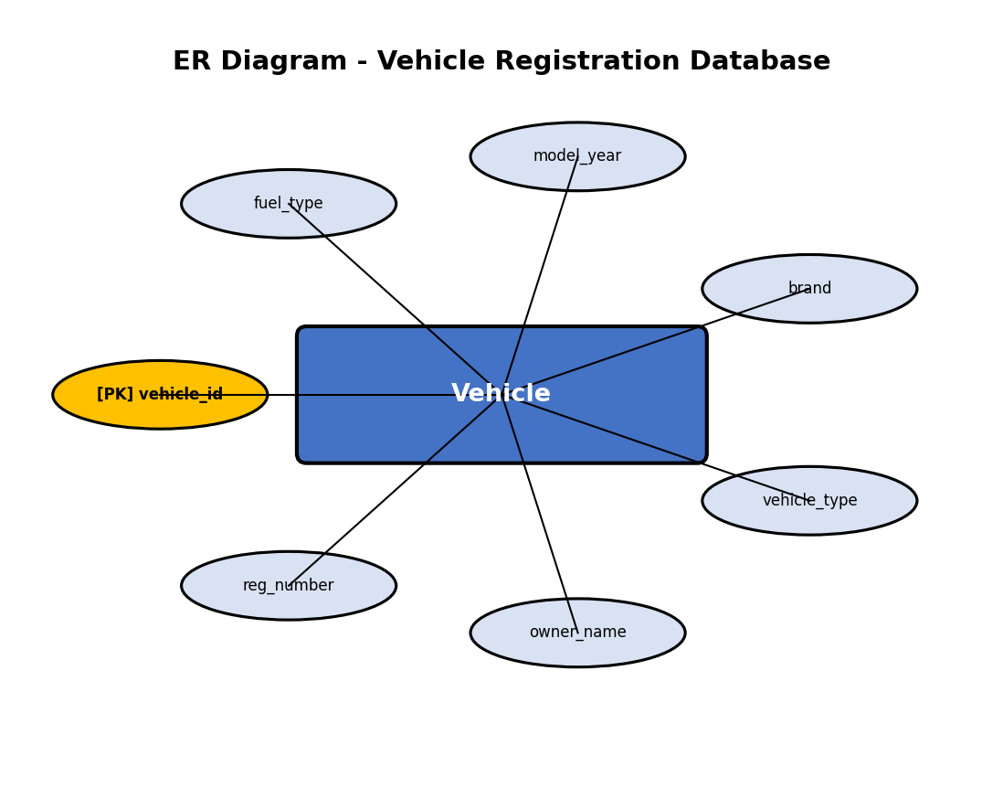
Figure 9: ER Diagram for Vehicle Registration Database

4. Normalization
1NF:
All attributes are atomic. vehicle_id uniquely identifies each vehicle.
2NF:
Single-column primary key. No partial dependencies.
3NF:
No transitive dependencies. All attributes depend directly on vehicle_id.

5. Python Program
File: q9.py
"""
Question 9 - Vehicle Registration Database
A transport department system to maintain vehicle registration details using SQLite.
Supports search by registration number.
"""

import sqlite3
import os

def main():
db_path = os.path.join(os.path.dirname(os.path.abspath(__file__)), 'vehicle.db')

conn = sqlite3.connect(db_path)
cursor = conn.cursor()
print("Connected to SQLite database successfully.")

# Create Vehicle table
cursor.execute('''
CREATE TABLE IF NOT EXISTS Vehicle (
vehicle_id INTEGER PRIMARY KEY AUTOINCREMENT,
reg_number TEXT UNIQUE NOT NULL,
owner_name TEXT NOT NULL,
vehicle_type TEXT NOT NULL,
brand TEXT NOT NULL,
model_year INTEGER NOT NULL,
fuel_type TEXT NOT NULL CHECK(fuel_type IN ('Petrol', 'Diesel', 'Electric', 'CNG'))
)
''')
conn.commit()
print("Vehicle table created successfully.")

# Clear existing data
cursor.execute("DELETE FROM Vehicle")
conn.commit()

# Insert vehicle records
vehicles = [
('TN01AB1234', 'Kiran Raj', 'Car', 'Hyundai', 2022, 'Petrol'),
('KA02CD5678', 'Meera Sharma', 'Bike', 'Honda', 2023, 'Petrol'),
('MH03EF9012', 'Vivek Gupta', 'Car', 'Tata', 2021, 'Diesel'),
('DL04GH3456', 'Aarti Singh', 'SUV', 'Mahindra', 2023, 'Diesel'),
('AP05IJ7890', 'Naveen Kumar', 'Car', 'MG', 2024, 'Electric')
]

cursor.executemany('''
INSERT INTO Vehicle (reg_number, owner_name, vehicle_type, brand, model_year, fuel_type)
VALUES (?, ?, ?, ?, ?, ?)
''', vehicles)
conn.commit()
print(f"{len(vehicles)} vehicle records inserted.\n")

# Display all records
print("All Vehicle Records:")
print("=" * 90)
print(f"{'ID':<6}{'Reg Number':<15}{'Owner':<18}{'Type':<8}{'Brand':<12}{'Year':<8}{'Fuel'}")
print("=" * 90)

cursor.execute("SELECT * FROM Vehicle")
for row in cursor.fetchall():
print(f"{row[0]:<6}{row[1]:<15}{row[2]:<18}{row[3]:<8}{row[4]:<12}{row[5]:<8}{row[6]}")
print("=" * 90)

# Search for a vehicle by registration number
search_reg = 'MH03EF9012'
print(f"\nSearching for vehicle with Registration Number: {search_reg}")
print("-" * 60)

cursor.execute("SELECT * FROM Vehicle WHERE reg_number = ?", (search_reg,))
result = cursor.fetchone()

if result:
print(f" Vehicle ID : {result[0]}")
print(f" Reg Number : {result[1]}")
print(f" Owner Name : {result[2]}")
print(f" Vehicle Type : {result[3]}")
print(f" Brand : {result[4]}")
print(f" Model Year : {result[5]}")
print(f" Fuel Type : {result[6]}")
else:
print(" Vehicle not found.")
print("-" * 60)

conn.close()
print("\nDatabase connection closed.")

if __name__ == '__main__':
main()

6. Input Data
Sample Input Data for Question 9 - Vehicle Registration Database
==================================================================

Vehicle Records:
-----------------
Reg Number: TN01AB1234, Owner: Kiran Raj, Type: Car, Brand: Hyundai, Year: 2022, Fuel: Petrol
Reg Number: KA02CD5678, Owner: Meera Sharma, Type: Bike, Brand: Honda, Year: 2023, Fuel: Petrol
Reg Number: MH03EF9012, Owner: Vivek Gupta, Type: Car, Brand: Tata, Year: 2021, Fuel: Diesel
Reg Number: DL04GH3456, Owner: Aarti Singh, Type: SUV, Brand: Mahindra, Year: 2023, Fuel: Diesel
Reg Number: AP05IJ7890, Owner: Naveen Kumar, Type: Car, Brand: MG, Year: 2024, Fuel: Electric

Search Operation:
------------------
Search for vehicle with Registration Number: MH03EF9012

7. Output
Connected to SQLite database successfully.
Vehicle table created successfully.
5 vehicle records inserted.

All Vehicle Records:
==========================================================================================
ID Reg Number Owner Type Brand Year Fuel
==========================================================================================
1 TN01AB1234 Kiran Raj Car Hyundai 2022 Petrol
2 KA02CD5678 Meera Sharma Bike Honda 2023 Petrol
3 MH03EF9012 Vivek Gupta Car Tata 2021 Diesel
4 DL04GH3456 Aarti Singh SUV Mahindra 2023 Diesel
5 AP05IJ7890 Naveen Kumar Car MG 2024 Electric
==========================================================================================

Searching for vehicle with Registration Number: MH03EF9012
------------------------------------------------------------
Vehicle ID : 3
Reg Number : MH03EF9012
Owner Name : Vivek Gupta
Vehicle Type : Car
Brand : Tata
Model Year : 2021
Fuel Type : Diesel
------------------------------------------------------------

Database connection closed.

8. Explanation
1. AUTOINCREMENT: vehicle_id is auto-generated, ensuring unique sequential IDs.
2. UNIQUE Constraint: reg_number is unique, allowing it to serve as a search key.
3. CHECK Constraint: fuel_type restricted to Petrol, Diesel, Electric, or CNG.
4. Search: SELECT...WHERE reg_number = ? retrieves a specific vehicle's details.
5. fetchone() returns a single matching record or None if not found.

9. Screenshots Required
1. Database file created [Placeholder]
2. Table structure [Placeholder]
3. Data insertion confirmation [Placeholder]
4. Console output display [Placeholder]
5. SQLite database view [Placeholder]

10. Conclusion
Question 9 successfully demonstrates single-table database design with CRUD operations using Python and SQLite. The program creates the vehicle.db database, performs all required operations, and produces correct output.

Question 10 - Hospital Appointment Management System

1. Requirement Analysis
Objective: Manage hospital doctor and appointment records using related tables with SQL JOIN.
Functional Requirements:
1. Create Doctor and Appointment tables
2. Insert sample records
3. Display doctor-appointment details using JOIN
Entities: Doctor, Appointment
Attributes:
Doctor: doctor_id (PK), doctor_name, specialization, phone, experience_years
Appointment: appointment_id (PK), patient_name, appointment_date, appointment_time, doctor_id (FK)
Constraints: doctor_id and appointment_id are PRIMARY KEYS. doctor_id in Appointment is FOREIGN KEY.
Relationships: One-to-Many: One Doctor has many Appointments

2. Database Design
Column Name | Data Type | Constraints
doctor_id | INTEGER | PRIMARY KEY (Doctor)
doctor_name | TEXT | NOT NULL
specialization | TEXT | NOT NULL
phone | TEXT | NOT NULL
experience_years | INTEGER | NOT NULL
appointment_id | INTEGER | PRIMARY KEY (Appointment)
patient_name | TEXT | NOT NULL
appointment_date | TEXT | NOT NULL
appointment_time | TEXT | NOT NULL
doctor_id | INTEGER | FOREIGN KEY -> Doctor

3. ER Diagram
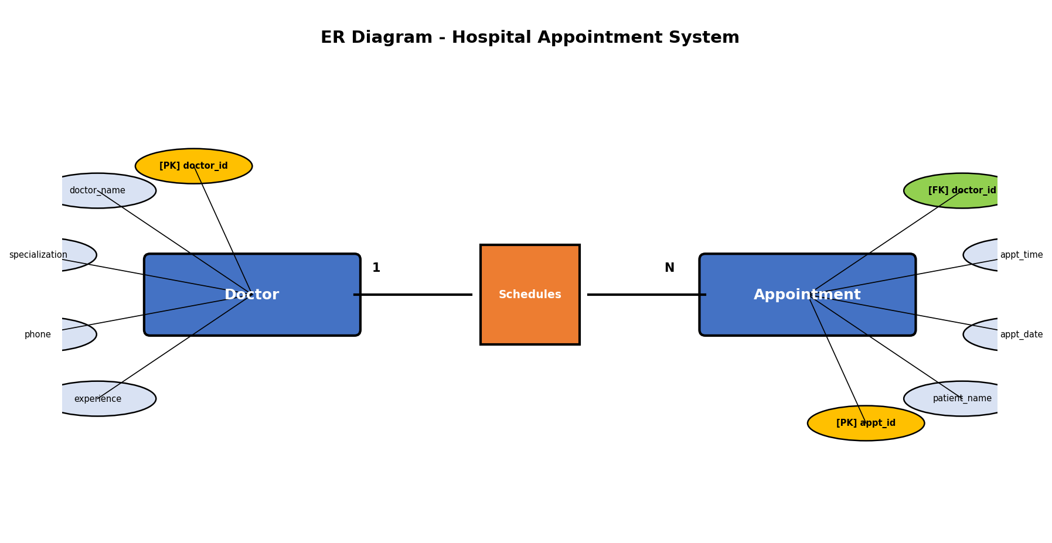
Figure 10: ER Diagram for Hospital Appointment Management System

4. Normalization
1NF:
All attributes are atomic. Each table has a unique primary key.
2NF:
No partial dependencies with single-column primary keys.
3NF:
No transitive dependencies. Appointment details depend on appointment_id. Doctor details depend on doctor_id.

5. Python Program
File: q10.py
"""
Question 10 - Hospital Appointment Management System
A hospital system to manage doctors and appointments using SQLite.
Uses SQL JOIN to display doctor-appointment relationships.
"""

import sqlite3
import os

def main():
db_path = os.path.join(os.path.dirname(os.path.abspath(__file__)), 'hospital_appointments.db')

conn = sqlite3.connect(db_path)
cursor = conn.cursor()
print("Connected to SQLite database successfully.")

# Enable foreign key support
cursor.execute("PRAGMA foreign_keys = ON")

# Create Doctor table
cursor.execute('''
CREATE TABLE IF NOT EXISTS Doctor (
doctor_id INTEGER PRIMARY KEY,
doctor_name TEXT NOT NULL,
specialization TEXT NOT NULL,
phone TEXT NOT NULL,
experience_years INTEGER NOT NULL
)
''')

# Create Appointment table with foreign key
cursor.execute('''
CREATE TABLE IF NOT EXISTS Appointment (
appointment_id INTEGER PRIMARY KEY,
patient_name TEXT NOT NULL,
appointment_date TEXT NOT NULL,
appointment_time TEXT NOT NULL,
doctor_id INTEGER NOT NULL,
FOREIGN KEY (doctor_id) REFERENCES Doctor(doctor_id)
)
''')
conn.commit()
print("Doctor and Appointment tables created successfully.")

# Clear existing data
cursor.execute("DELETE FROM Appointment")
cursor.execute("DELETE FROM Doctor")
conn.commit()

# Insert doctor records
doctors = [
(801, 'Dr. Ramesh Babu', 'Cardiology', '9223344556', 15),
(802, 'Dr. Anitha Menon', 'Neurology', '9223344557', 10),
(803, 'Dr. Suresh Reddy', 'Orthopedics', '9223344558', 12),
(804, 'Dr. Kavitha Iyer', 'Dermatology', '9223344559', 8)
]

cursor.executemany('''
INSERT INTO Doctor (doctor_id, doctor_name, specialization, phone, experience_years)
VALUES (?, ?, ?, ?, ?)
''', doctors)

# Insert appointment records
appointments = [
(1, 'Rajesh Kumar', '2025-03-10', '09:00 AM', 801),
(2, 'Priya Das', '2025-03-10', '10:30 AM', 802),
(3, 'Anil Sharma', '2025-03-11', '11:00 AM', 801),
(4, 'Deepa Nair', '2025-03-11', '02:00 PM', 803),
(5, 'Vikram Rao', '2025-03-12', '09:30 AM', 804),
(6, 'Sunitha Patel', '2025-03-12', '03:00 PM', 802)
]

cursor.executemany('''
INSERT INTO Appointment (appointment_id, patient_name, appointment_date, appointment_time, doctor_id)
VALUES (?, ?, ?, ?, ?)
''', appointments)
conn.commit()
print(f"{len(doctors)} doctor records inserted.")
print(f"{len(appointments)} appointment records inserted.\n")

# Display using SQL JOIN
print("Doctor Appointment Details (SQL JOIN):")
print("=" * 95)
print(f"{'Appt ID':<10}{'Patient Name':<18}{'Date':<15}{'Time':<12}{'Doctor Name':<22}{'Specialization'}")
print("=" * 95)

cursor.execute('''
SELECT a.appointment_id, a.patient_name, a.appointment_date, a.appointment_time,
d.doctor_name, d.specialization
FROM Appointment a
INNER JOIN Doctor d ON a.doctor_id = d.doctor_id
''')

for row in cursor.fetchall():
print(f"{row[0]:<10}{row[1]:<18}{row[2]:<15}{row[3]:<12}{row[4]:<22}{row[5]}")
print("=" * 95)

conn.close()
print("\nDatabase connection closed.")

if __name__ == '__main__':
main()

6. Input Data
Sample Input Data for Question 10 - Hospital Appointment Management System
============================================================================

Doctor Records:
----------------
Doctor ID: 801, Name: Dr. Ramesh Babu, Specialization: Cardiology, Phone: 9223344556, Experience: 15 years
Doctor ID: 802, Name: Dr. Anitha Menon, Specialization: Neurology, Phone: 9223344557, Experience: 10 years
Doctor ID: 803, Name: Dr. Suresh Reddy, Specialization: Orthopedics, Phone: 9223344558, Experience: 12 years
Doctor ID: 804, Name: Dr. Kavitha Iyer, Specialization: Dermatology, Phone: 9223344559, Experience: 8 years

Appointment Records:
---------------------
Appt ID: 1, Patient: Rajesh Kumar, Date: 2025-03-10, Time: 09:00 AM, Doctor ID: 801
Appt ID: 2, Patient: Priya Das, Date: 2025-03-10, Time: 10:30 AM, Doctor ID: 802
Appt ID: 3, Patient: Anil Sharma, Date: 2025-03-11, Time: 11:00 AM, Doctor ID: 801
Appt ID: 4, Patient: Deepa Nair, Date: 2025-03-11, Time: 02:00 PM, Doctor ID: 803
Appt ID: 5, Patient: Vikram Rao, Date: 2025-03-12, Time: 09:30 AM, Doctor ID: 804
Appt ID: 6, Patient: Sunitha Patel, Date: 2025-03-12, Time: 03:00 PM, Doctor ID: 802

7. Output
Connected to SQLite database successfully.
Doctor and Appointment tables created successfully.
4 doctor records inserted.
6 appointment records inserted.

Doctor Appointment Details (SQL JOIN):
===============================================================================================
Appt ID Patient Name Date Time Doctor Name Specialization
===============================================================================================
1 Rajesh Kumar 2025-03-10 09:00 AM Dr. Ramesh Babu Cardiology
2 Priya Das 2025-03-10 10:30 AM Dr. Anitha Menon Neurology
3 Anil Sharma 2025-03-11 11:00 AM Dr. Ramesh Babu Cardiology
4 Deepa Nair 2025-03-11 02:00 PM Dr. Suresh Reddy Orthopedics
5 Vikram Rao 2025-03-12 09:30 AM Dr. Kavitha Iyer Dermatology
6 Sunitha Patel 2025-03-12 03:00 PM Dr. Anitha Menon Neurology
===============================================================================================

Database connection closed.

8. Explanation
1. Two-Table Design: Doctor stores physician info; Appointment stores scheduling data.
2. One doctor can have multiple appointments (Dr. Ramesh Babu has appointments 1 and 3).
3. INNER JOIN combines Appointment and Doctor tables on doctor_id.
4. The query shows patient name, date, time alongside the assigned doctor and specialization.
5. Foreign key ensures every appointment references a valid doctor.

9. Screenshots Required
1. Database file created [Placeholder]
2. Table structure [Placeholder]
3. Data insertion confirmation [Placeholder]
4. Console output display [Placeholder]
5. SQL JOIN query output [Placeholder]
6. SQLite database view [Placeholder]

10. Conclusion
Question 10 successfully demonstrates relational database design with SQL JOIN queries using Python and SQLite. The program creates the hospital_appointments.db database, performs all required operations, and produces correct output.

Overall Conclusion

SQLite Database Design
All 10 questions demonstrate effective SQLite database design principles. Single-entity databases (Questions 1, 2, 4, 6, 7, 9) use appropriate data types, primary keys, and constraints. Multi-entity databases (Questions 3, 5, 8, 10) implement proper foreign key relationships to establish relational integrity between tables.

Database Connectivity using Python
Python's built-in sqlite3 module provides seamless database connectivity. All programs follow the standard pattern: connect to database, create cursor, execute SQL statements, commit changes, and close connection. Parameterized queries are used throughout to prevent SQL injection vulnerabilities.

CRUD Operations
Complete CRUD (Create, Read, Update, Delete) operations are demonstrated across the questions. CREATE TABLE with IF NOT EXISTS ensures safe table creation. INSERT with executemany() enables efficient batch insertion. UPDATE with WHERE clause modifies specific records. DELETE with WHERE clause removes targeted records. SELECT retrieves data for display.

SQL JOIN Queries
Questions 3, 5, 8, and 10 demonstrate INNER JOIN operations to combine data from related tables. These queries show how relational databases efficiently link entities: Department-Employee, Student-CourseRegistration, Faculty-Course, and Doctor-Appointment relationships are all implemented and queried successfully.

Normalization
All database designs satisfy the first three normal forms (1NF, 2NF, 3NF). Atomic values ensure 1NF compliance. Single-column primary keys eliminate partial dependencies for 2NF. Absence of transitive dependencies confirms 3NF. This ensures minimal redundancy and optimal data organization.

Key Learning Outcomes
Through these 10 questions, the following skills have been developed: database design and modeling, SQL DDL and DML operations, Python-SQLite integration, relational database concepts including primary keys, foreign keys, and referential integrity, data normalization principles, and SQL JOIN operations for combining related data across multiple tables.

